Raymond You

Pre-Lab Assignment 3

Professor Kimani

Pre 3.1)

a)

-A PWM signal is a modulation technique that transforms the width of a pulse, based on the modulator signal information. Modulation is the process of switching an electronic device in a power electronic converter from one state to another.

-The PWM duty cycle describes the proportion of “ON” time versus “OFF” time over the period of the cycle, usually expressed as a percent with 100% being fully on for the entire period. The duty cycle is an important factor for controlling a device using PWM.

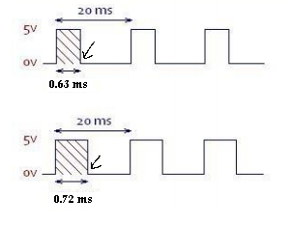b)

Duty cycle of 3%

On duration: 0.63 ms

Off duration: 20 ms – 0.63 =19.37 ms

Duty cycle of 12%

On duration: 0.72 ms

Off duration: 20 ms – 0.72 =19.28 ms

c)

//calculate the on period of a PWM signal for controlling a servomotor

//receives the servo position (0 to 180 degrees) and returns the time

//in microseconds that PWM signal should be on during each period

//so that the RC servo moves to the specified servo position

double degreeToOneDelay(int angle) {

if(angle < 0 || angle > 180) {

return;

}

else {

return 0.6 + (double)angle/100;

}

}

Pre 3.2)

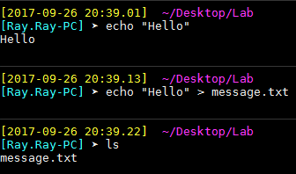

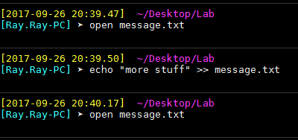

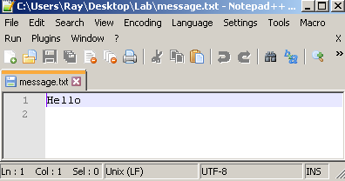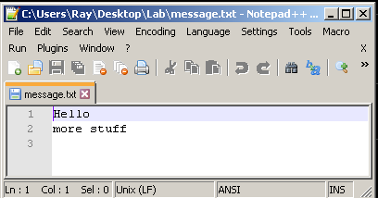

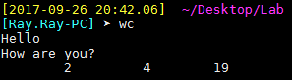



In Lab 3.5, it uses the > command to redirect numbers or commands such as 13, 10, 11, 12, out to locations such as #FILEPATH/unexport, $FILEPATH/export, etc.